Does the number of badges increase price?

·       Introduce the problem and define "badges" as well as their purchase.

In Whole Foods most of the catalogue shows the client a variety of badges or tags, based on recommended dietary preferences. Dietary preferences are defined as the removal of certain consumption habits due to health requirements, own preferences or doctor orders. These preferences are named and shown in the Whole Foods PDP (Product Detail Page) to inform customers which products check certain dietary preferences. Since this could lead to possible price increase due to higher costs of production, trends, etc. we set a hypothesis as to whether Whole Foods took advantage of these tags to pump up prices.

According to an article in ScienceDirect.com, *“One of the main differentiators of food preferences is culture. Elizabeth Rozin has argued that different food preferences are basically rooted in differing flavor principles among cuisines.*” (Meiselman, 2017). As per Medium.com, the most common dietary preference in the United States is Low-Carb followed by High- Protein and low- sodium.

·       Answer the business question: Does the number of badges increase price?

To answer this, it’s key to understand how the database is conformed. We have 834 products from 17 different categories which were sampled in a way in which we could have as much information from each of them, including which badges they had. 12 different badges were the maximum amount, and 5 badges were the most common amount followed by 6 and 4. Since by “badges” we are talking about dietary preferences, the “Local” and “USDA Organic” product badge is not included in this part of the analysis.

Based on an analysis in SQL, we see that the average price of products with badges is higher than the average of products without, with an average price of $7.75 for products with badges and $6.9 from products without them. To make sure this average was correct and significant, running a hypothesis test in Excel was key. For this, the products were divided in quartiles and later tested by a regression and t-test. Even if the result of the regression test showed that the number of badges was related to the price, no quartile showed to be statistical significant between badge count and average price.

·       Provide your top two actionable insights.

1.

According to Front Office Sports, a website dedicated to informing on everything related to sports, including markets, retail, trends, etc. the Sport Nutrition industry was valued at $44.43 billion in 2021 and expected to reach $85.7 by 2030. With this 7.57% CAGR it’s a clear industry in which Whole Foods could take advantage off.

Based on our research and sampling, supplements represent almost 4% of the whole catalogue but if we go deep into the Sports Nutrition & Weight Management subcategory, it's only 2%. Not only is there a big increase in the Sport Nutrition industry but also, for Whole Foods, Supplements have the highest average price per tag in their website and average price per product which could indicate a high willingness to pay by the customers. Inside the subcategory, their own white label, 365 by Whole Foods Market, represents almost 14% of their catalogue. If Whole Foods created more variations of their products to help the category grow, they could end up as leaders vs the other brands.

2.

Whole Foods as a company, have in their company values, as follows: “…have an unshakeable commitment to sustainable agriculture”. Nowadays, sustainable agriculture products are a trend in high social-economic society. Sustainable agriculture is defined as “*Sustainable agricultural practices are intended to protect the environment, expand the Earth’s natural resource base, and maintain and improve soil fertility*” (Sustainable Agriculture 2022).

With the increase in plant- based meals, a new sustainable problem has risen. “*Plant-based meat sales hit $1.4 billion in 2020—a 45 percent increase over 2019. And meat alternatives have plenty of company in the larger plant-based food market, which grew 27 percent in 2020 to reach $7 billion. Plant-based milk sales, fueled by rising interest in oat milk, continue to dominate with a 20 percent increase that tracked to $2.5 billion in 2020 retail sales.*” (Hansen, 2022)

Whole Foods could implement a new badge regarding Sustainable Agriculture in order to inform customers how their future product was produced. In fact, the USDA could certify Whole Food suppliers and their products would go with the “Sustainable Agriculture” badge.

**REFERENCES**

Meiselman, H. L. (2017). *Food preference/ Eating Habits*. Food Preference - an overview | ScienceDirect Topics. Retrieved December 11, 2022, from https://www.sciencedirect.com/topics/medicine-and-dentistry/food-preference

Ainbinder, R. (2022, September 16). *Why Sports Nutrition is a booming market*. Front Office Sports. Retrieved December 11, 2022, from https://frontofficesports.com/pro-archive/why-sports-nutrition-is-a-booming-market/

*Sustainable Agriculture*. Nation Institute of Food and Agriculture. (n.d.). Retrieved December 11, 2022, from https://www.nifa.usda.gov/topics/sustainable-agriculture

Hansen, J. (2022, September 30). *6 ways sustainable agriculture is changing the business of food*. Means and Matters. Retrieved December 11, 2022, from https://meansandmatters.bankofthewest.com/article/financial-perspectives/industries/6-ways-sustainable-agriculture-is-changing-the-business-of-food/

**APPENDIX**

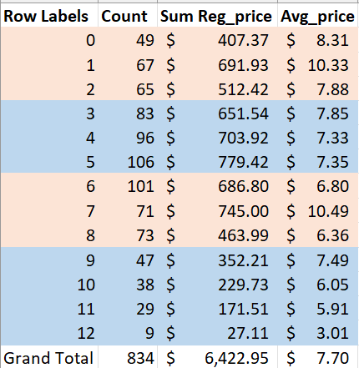

1. Products Per number of badges.

1. Regression Analysis Based on Price and Count of Badges

1. Hypothesis Testing

1. AVG price per count of badges

1. Top 10 categories with more than 30 products in which the price x badge within the category is the highest